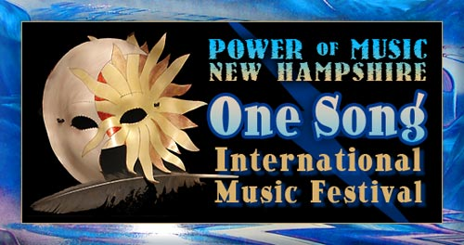
with Innovations for Humanity Summit, Exposition & Conference

Welcome to the Premiere Event!

Dear Like-Minded Friends,
Welcome to the most exciting concept in the festival entertainment market. Because you care about our teens and the future of our planet, please consider sharing our dream.
One-Song International Festival's spirit of collaboration and marketing are unique. Most events are like spectator sports. One-Song makes every participant part of the music.
From the exciting opening World Sound drum ceremony, when everyone joins to shake, rattle and roll percussion instruments, to the collaborative performance of the original Grand Finale “One-Song,” dedicated to AmeriCorps, One-Song will energize the creative force within every attendee.
Our Innovations for Humanity Conference & Expos will bring practitioners and businesses to the attention of the communities that desperately need their help. Innovations for Humanity Summits will match entrepreneurial humanitarian projects with dedicated investors.
Many communities across America struggle to get past their diversity. Cultures and generations are polarized. One-Song provides the systems and spirit to bring us together. And most exciting, any regional community can host a One-Song event and everyone can participate. All communities and especially their teens will benefit.
In development since 1997, every aspect of this concept has been tested and the full concept presented in two large 3-day festivals. You benefit from our past success stories.
You have the opportunity to be part of the international launch. Enclosed are sponsorship packages, which allow businesses, individuals, and organizations to participate in their local communities or invest for the global ride.
Take a minute of your valuable time to consider our goals and how you can join with us and like-minded individuals and businesses.
With most events, when the event is over, so is the benefit of the sponsor's dollar. With Power of Music's One-Song International Festivals, the effect lives on and on. Our future depends on it!
I sincerely thank you for your interest,

Barbara Hughes

Founder of Power of Music’s One-Song International Festival
928-202-1447
b@powerofmusicnh.com
www.powerofmusicnh.com

SPONSORSHIP PACKAGES

The Whole Kitten Caboodle $315,000 or more
Sponsor the entire event!
You’re the cat, the wild side child who call the shots, the independently mysterious one, who knows with 9 lives, you can have it all. The more we receive, the more we can do to help others.

Grand Pooh-Bah: Grand Finale Ceremony $175,000
Included in the Grand Pooh-Bah:
Sponsor the cost of T’shirts for staff and participants, CD Duplication, and Percussion Instruments - $75,000
Sponsor the National Act, Mystery Band, plus the On Air Soap Opera promotion that leads up to it - $75,000
Teen-Power of Music Recording, Theme: The Mask - $5,000
Theme Song, One-Song Recording - $5,000
Unmasking Masks for finale - $15,000

The Big Cheese $50,000
Smile, you’re on One Song Camera!
Help sponsor video footage of the event, multiple cameras on stage live, and for Steve Simons’ production and editing.

Hound Dog $20,000
Power of Music Publishing Division Launch
Yes, you’re the top hog, king of the hill, and leader of the pack sponsoring the best new author submissions in various categories. Publishing to promote the Power of Music Books “by”, “about” and “for” Power of Music kids, parents, and teachers.

Do you Speak BE? $15,000
Power of Words Division Launch
Sponsor the cost of Writing workshops for teens and adults using words to create and heal

Dream Weaver $25,000
World Wide Web Launch
Oh the webs we weave, the networks we achieve, of our connected, creative minds. Creating a powerful presence for divisions and programs; Websites, blogs, and “social media” presence to get the message out!

B’s Vibrational Genius $15,000
The Music Never Lies
Sponsor a recording package for the best new original musical artist who pours it through one’s heart-chakra, and creates the highest goose-bump level.

Connie’s Stroke of Brilliance $15,000
Visual Arts Scholarship
In the fine contours of your mind, the beauty of life resides, with brush strokes and canvas display, to color the world whole again.

TRADITIONAL SPONSORSHIP PACKAGES
Platinum $37,500 (3 available)
Gold $10,000 (6 available)
Silver $3,750 (12 available)
Band $500 - $1500

