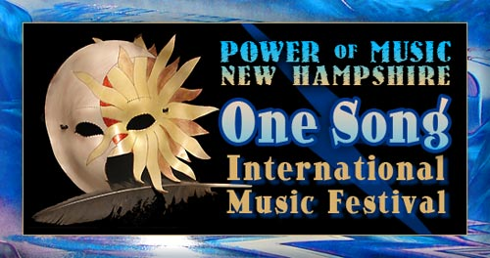
with Innovations for Humanity Summit, Exposition & Conference

Welcome to the Premiere Event!

Dear Like-Minded Friends,
Welcome to the most exciting concept in the festival entertainment market. Because you care about our teens and the future of our planet, please consider sharing our dream.
One-Song International Festival's spirit of collaboration and marketing are unique. Most events are like spectator sports. One-Song makes every participant part of the music.
From the exciting opening World Sound drum ceremony, when everyone joins to shake, rattle and roll percussion instruments, to the collaborative performance of the original Grand Finale “One-Song,” dedicated to AmeriCorps, One-Song will energize the creative force within every attendee.
Our Innovations for Humanity Conference & Expos will bring practitioners and businesses to the attention of the communities that desperately need their help. Innovations for Humanity Summits will match entrepreneurial humanitarian projects with dedicated investors.
Many communities across America struggle to get past their diversity. Cultures and generations are polarized. One-Song provides the systems and spirit to bring us together. And most exciting, any regional community can host a One-Song event and everyone can participate. All communities and especially their teens will benefit.
In development since 1997, every aspect of this concept has been tested and the full concept presented in two large 3-day festivals. You benefit from our past success stories.
You have the opportunity to be part of the international launch. Enclosed are sponsorship packages, which allow businesses, individuals, and organizations to participate in their local communities or invest for the global ride.
Take a minute of your valuable time to consider our goals and how you can join with us and like-minded individuals and businesses.
With most events, when the event is over, so is the benefit of the sponsor's dollar. With Power of Music's One-Song International Festivals, the effect lives on and on. Our future depends on it!
I sincerely thank you for your interest,

Barbara Hughes

Founder of Power of Music’s One-Song International Festival
928-202-1447
b@powerofmusicnh.com
www.powerofmusicnh.com

Silver Sponsor

Only 12 Available

Advertising Markets:
Radio: Boston, Maine, New Hampshire
Print: Boston, Maine, New Hampshire
Additional: Web, Cable and pre-event marketing

Package:
- “Thank You “Power of Music” Poster, distributed after event
- Link on Power of Music website
- 1/4 page ad in program guide
- 5 VIP passes
- Signage at Event
- Booth at the exposition
- Mentions on “Power of Music” Video, distributed after the event
- Radio Raffle Opportunities

Value: $15,000
Silver Price: $3,750

A 25% deposit is received upon signing of this contract = $937.50 U.S.D. The remaining amount is due 30 days from date of contract.

________________________________
Company Name

________________________________
Your Name

________________________________
Date

________________________________
Title

________________________________
Power of Music Representative

________________________________
Date

