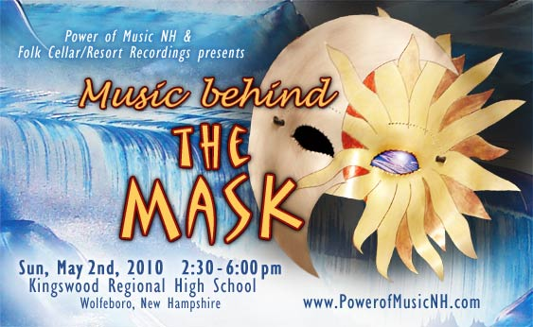
Copyright 2010 Power of Music New Hampshire P.O. Box 278, 61 Central Avenue Wolfeboro, NH 03894
www.PowerofMusicNH.com b@PowerofMusicNH.com 928-202-1447

Dear Friends:

Welcome to the first “Community Unity” spectacular! May this be the beginning of new partnerships, and a demonstration to the young people that we are able to come together for the benefit of all, in an inspiring way!
Below are opportunities to be included to support this production, whose benefits will last long after the event is over! All sponsors for the May 2nd show will have first right of refusal on our future productions.
Thank you for your openness and participation,
B. Hughes - Power of Music NH
928-202-1447
b@powerofmusicnh.com
www.powerofmusicnh.com

Early ticket sales benefit local area youth organizations & programs. Remaining proceeds benefit internships/scholarships with Power of Music NH, The Folk Cellar/Resort Recordings & Wolfeboro Community T.V.

“Music behind the Mask”
Sunday, May 2, 2010 2:30 - 6pm
Sponsorship Opportunities:
Partial Sponsorships accepted - except on T-shirt Series

• Presenter Status begins at $5,000 - included on ALL advertisings & products
• “Behind the Mask” T-Shirts with your Logo
First Series Promotional Shirts - 6 sponsors on back - 44 shirts………….$125 each sponsor
Pre-Show Shirts: 250 shirts……………………………………………………$250 each sponsor
Final Shirt: Event and Post Event-Ongoing for as long as popular……….$400 each sponsor

• VIP Pre-Post Parties: Meet the artists and open jam……………………….$150
• “We Are Wolfeboro” - Community Song for Wolfeboro’s 250th & beyond.…$5,000
• “The Mask” Teen-Song CD’s - with your Logo (1,000 initial run).......……..$2,500
• “Behind the Mask” Posters (250).......................................................………$1,250
• “Behind the Mask” Tickets (800)........................................................………$1,000
• Radio Campaign 3-4 weeks, multiple stations up to 300 spots
(includes Live Remote during the event).........................................……$1,500 - $7,500
• Wolfeboro Community TV “Music Behind the Mask” Episodes
Sold at event, and after event...............................................................$500/episode
• All Sponsors receive home page banner & link on “Power of Music” website
and The Folk Cellar website
• Banner and exposure on sound stage – filmed live by Wolfeboro Community TV

A 50% deposit is received upon signing of this contract
The remaining amount is due 30 days from date of contract, unless otherwise negotiated.
I am committed to___________towards_________________________ Sponsorship Package.
_______________________________
Company Name
_______________________________ ________________________________
Your Name Signed:

_______________________________
Date
_______________________________ _______________________________
Power of Music NH ~ Barbara Hughes Date

